- The Monetary Policy Committee voted to keep Bank Rate at 5.25% at its meeting this week. But the minutes stated the decision was now "finely balanced" for some members who voted to keep rates on hold and pointed to the importance of the upcoming forecast update. Therefore, we maintain our forecast that the first rate cut is likely to come at the August meeting.
- This week's upside surprise in services inflation complicated matters for the MPC. Services prices are rising at only a slightly weaker m/m pace than last year's bumper increases. For the more hawkish MPC members, this reinforced their concerns about inflation persistence.
The Bank of England's June monetary policy decision was the week's main event. The Monetary Policy Committee had used its May meeting minutes to send a message that it was keen to cut Bank Rate this summer if the data remained supportive. But with this week seeing services inflation – one of the MPC's key measures of inflation persistence – come in well above the BoE's expectations for a second successive month, the chances of a rate cut this week were virtually non-existent. So the key question for June's meeting was whether these upside surprises had also derailed the prospect of an August rate cut.
In the event, the MPC voted 7-2 to keep Bank Rate unchanged at 5.25%. The minutes shed more light on the balance of views on the committee. As in May, Dave Ramsden and Swati Dhingra both voted for a 25bps cut. But the recent data seems to have split the remaining seven members into two distinct camps.
Of those who voted to keep rates unchanged again, the more hawkish members pointed to recent upside surprises for services inflation as evidence that high pay growth would maintain persistent upward pressure on underlying inflation. Indeed, while this week's inflation release showed that headline inflation had returned to the BoE's 2% target in May, services inflation only edged down to 5.7%, from 5.9% in April, and remained well above the latest BoE staff forecast. This year's m/m rises in services inflation have only been slightly lower than 2023's high outturns (Chart 1), and those in the more hawkish camp would need much more progress on this front before voting for a looser monetary policy stance.
Chart 1: The m/m rises in services prices this year have been almost as high as 2023's bumper readings
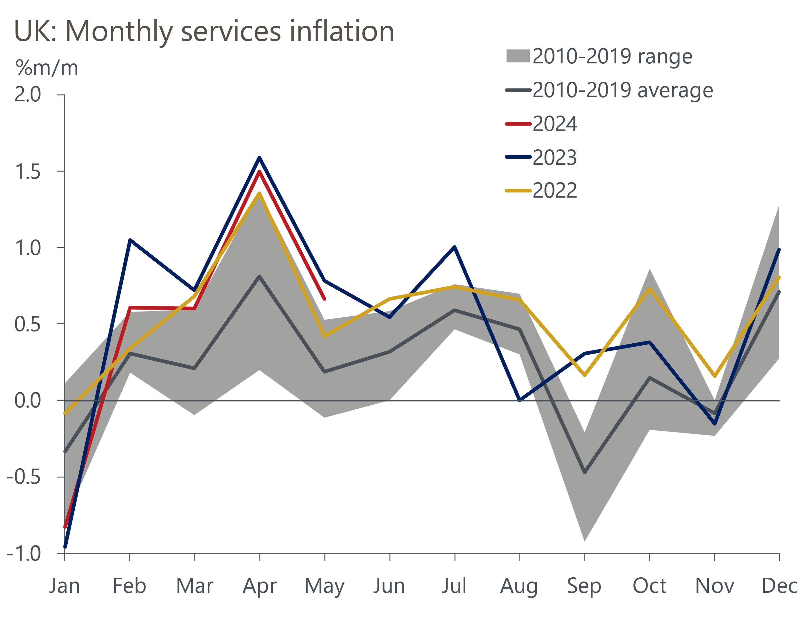
Source: Oxford Economics calculations using data from Haver Analytics

But the minutes suggested that other committee members downplayed the significance of stronger-than-expected services inflation, arguing that it "did not alter significantly the disinflationary trajectory that the economy was on". These members asserted that recent upside surprises were partly due to the impact of April's once-a-year price hikes for some goods and services, which reflect past inflation so should have limited implications for monetary policy. The blame was also pinned on movements in volatile components.
The BoE didn't identify how many committee members were in each camp. But when there is a major imbalance, the minutes would typically use "most" when describing the larger group. So the use of "some" and "others" suggests a fairly even split.
The prospect of an August rate cut hinges on at least three of the committee members who voted to keep rates on hold this week, changing their vote. We saw two key pieces of evidence to suggest that this shift is likely to occur. First, the minutes described June's decision as "finely balanced" for the members who downplayed the strength of recent data. Second, the minutes highlighted the importance of the August forecast round, which also indicated some committee members are preparing to change their vote. Considering the majority for an August cut would probably be 5-4, it's far from a done deal. But the MPC offered enough clues for us to maintain our forecast that Bank Rate will be lowered by 25bps in August and November, which would take the policy rate to 4.75% by year-end.
For this week's activity data, it was a case of having to look through month-to-month volatility to find underlying trends. Retail sales rose 2.9% in May, more than making up for the ground lost in April. But given how volatile the retail series has been recently, we don't read too much into the month's much stronger reading and continue to think the underlying story is one of gradual recovery after a tough couple of years. June's flash S&P Global survey saw the composite PMI fall to 51.7, from 53.0 in May, owing to a slower pace of growth in the services sector. But the PMIs are also very noisy month-to-month and the Q2 average was in line with Q1. Moreover, the relationship between the composite PMI and GDP is weak at best. Our main takeaway is that GDP is likely to grow at a decent pace in Q2, albeit more slowly than in Q1.
Finally, with the general election fast approaching, the state of the country's public finances is a hot topic. The latest figures showed public sector net borrowing (excluding public sector banks) was £15bn in May. This means that borrowing so far this fiscal year is running slightly higher than the OBR's forecast, a trend we expect to continue over the rest of this year. Further out, the fiscal outlook will remain uncertain until the new government lays out its plans. We've run the manifesto pledges of the Labour and Conservative parties through our Global Economic Model and found they would have a negligible impact on GDP growth and asset prices (Chart 2). Moreover, these new pledges pale in comparison to the 3% worth of fiscal tightening planned by the outgoing government, which both parties implicitly promise to implement. But we doubt either party would stick to its manifesto plans, particularly Labour if it wins a large majority.
Chart 2: The difference in GDP outcomes between current plans and the manifestos is negligible
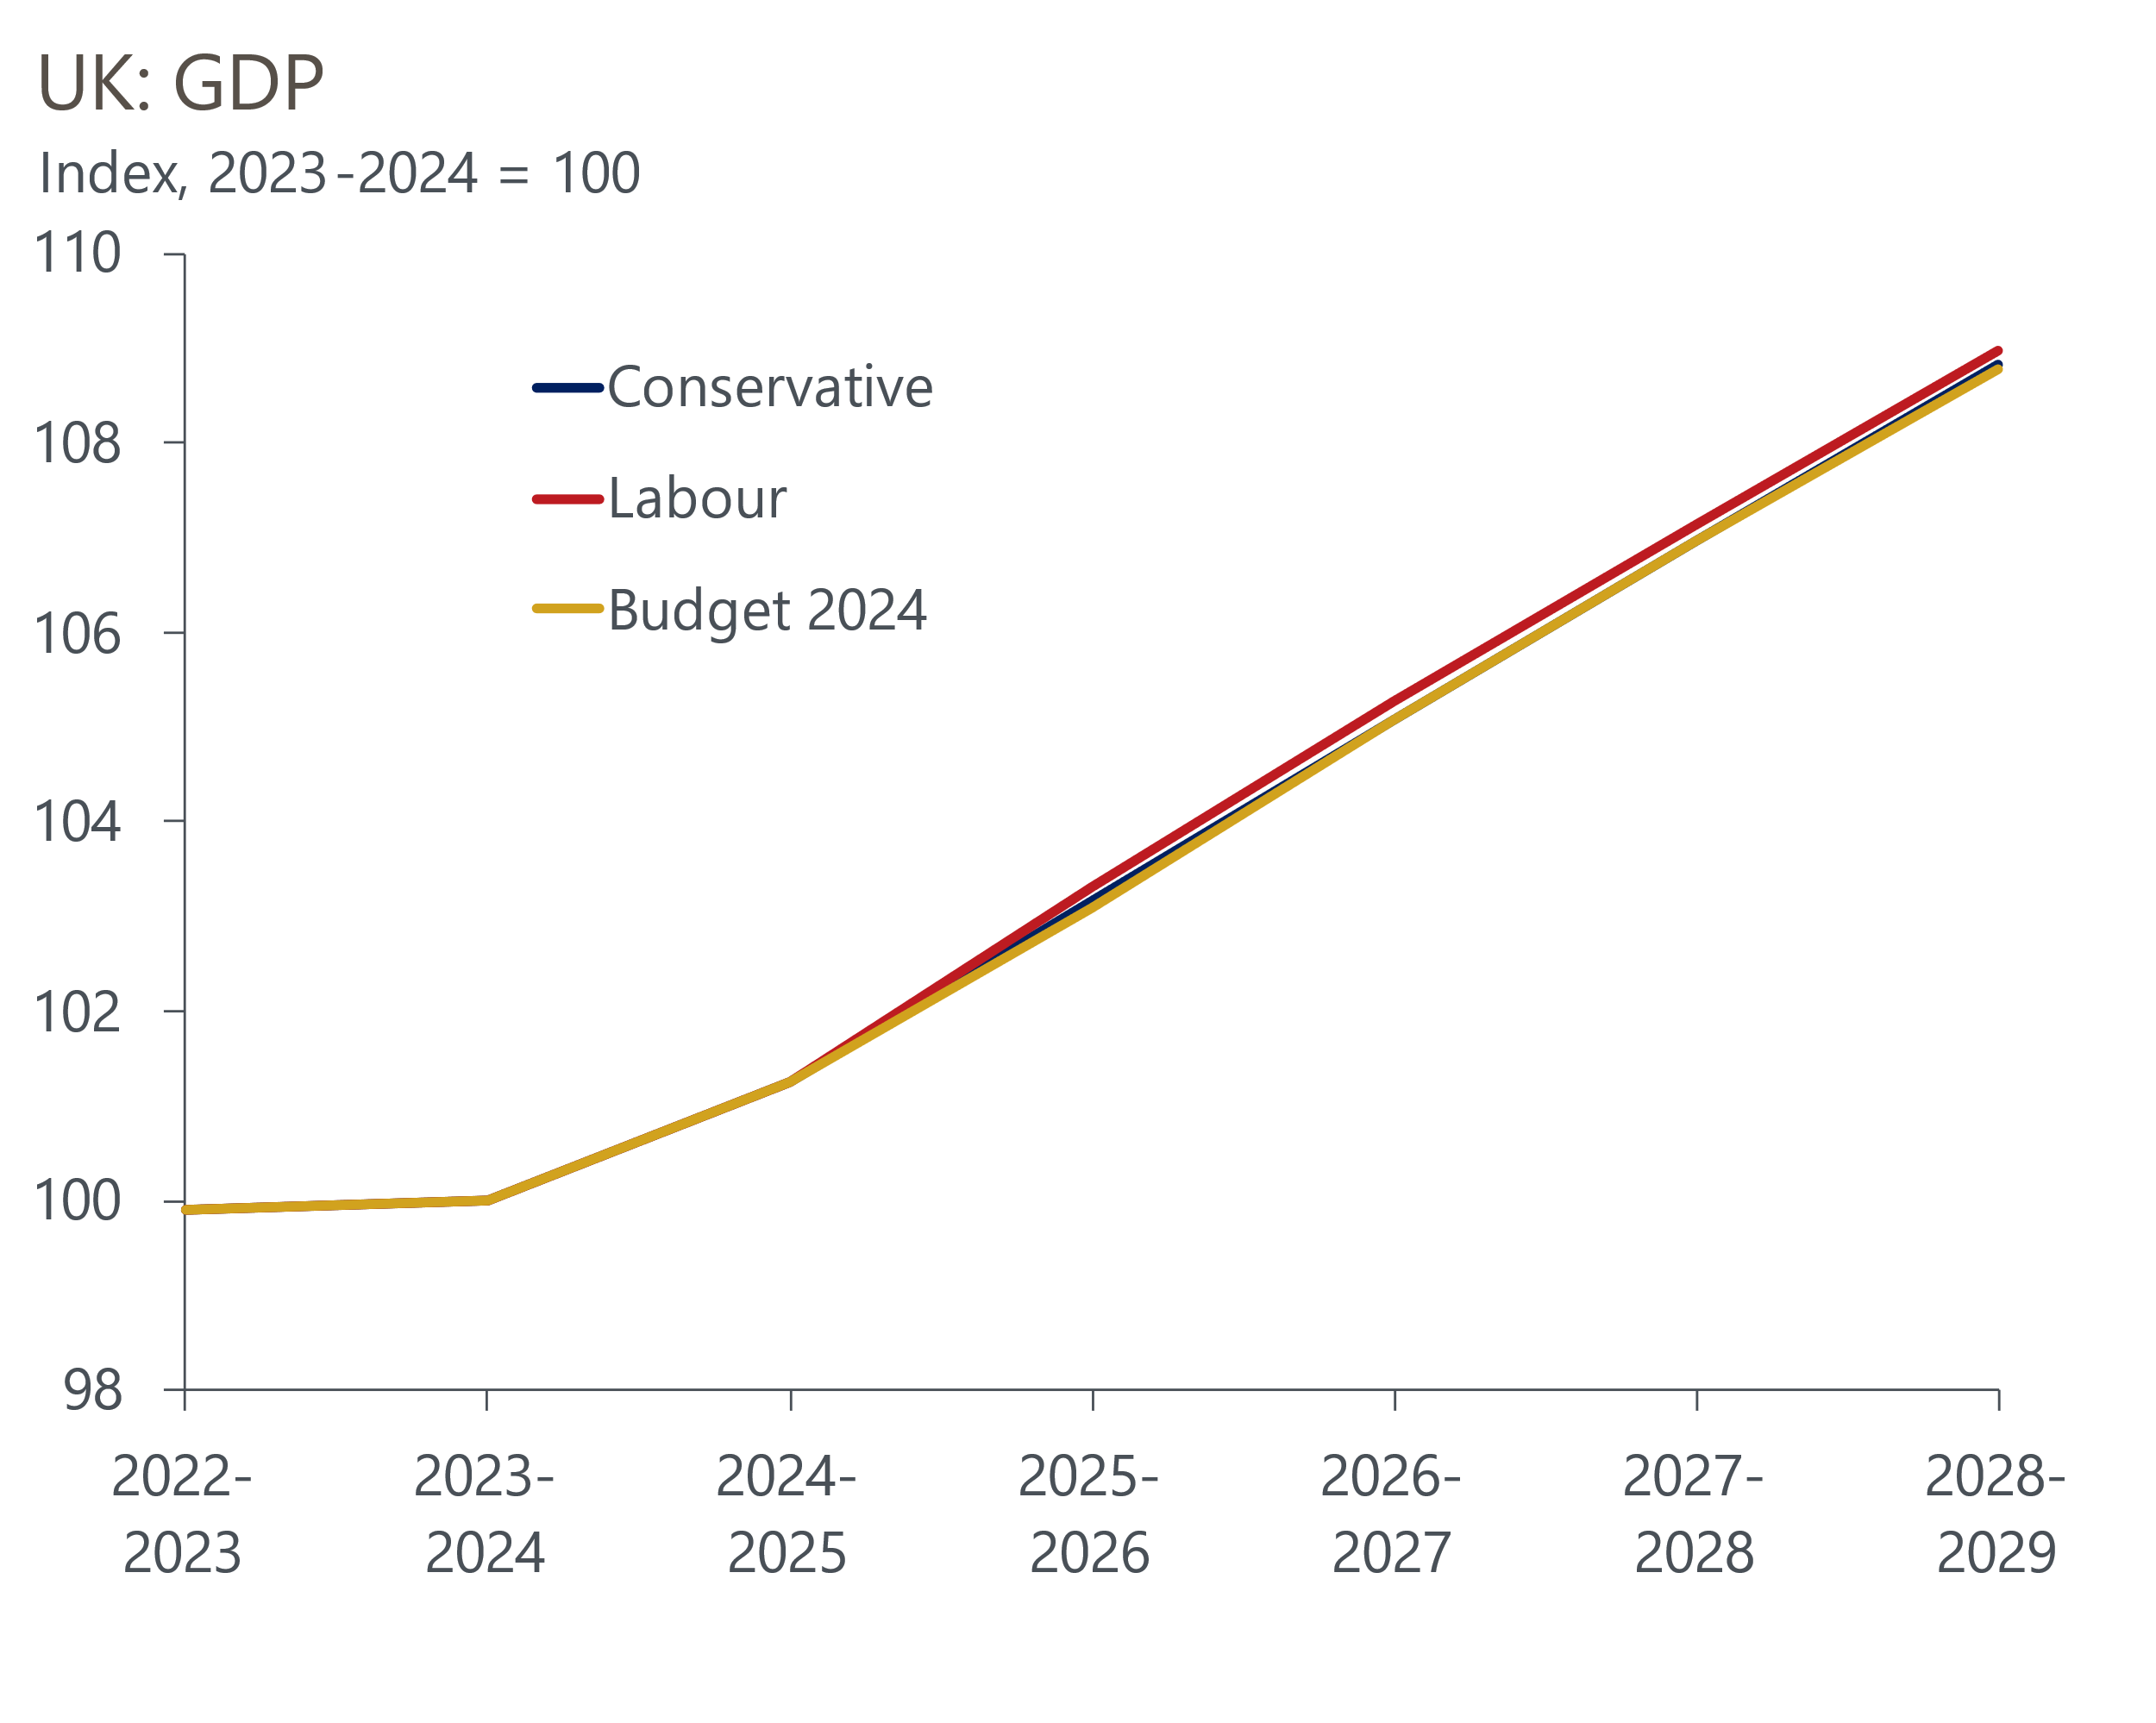
Source: Oxford Economics

The week ahead
Next week's only major data release is the Quarterly National Accounts for Q1 2024. This will see the Office for National Statistics take a second stab at estimating GDP, with its initial estimate having shown a robust expansion of 0.6% q/q. With there being no obvious reason to expect a revision in one direction over the other, we think the ONS will confirm that output in Q1 grew in line with its initial estimate. The release will also provide the first estimates for household income growth and the savings ratio for Q1.
Table 1: Week ahead calendar
Date | Events | Period | Measure | Unit | Previous | Forecast
Jun 28 | GDP | Q1 | q/q | % | 0.6 | 0.6
Jun 28 | GDP | Q1 | y/y | % | 0.2 | 0.2
Source: Oxford Economics

Key forecasts
Table 2: UK forecast overview
(Annual percentage changes unless specified)
 | 2022 | 2023 | 2024 | 2025 | 2026 | 2027
GDP | 4.3 | 0.1 | 0.9 | 2.0 | 1.9 | 1.6
Private consumption | 4.8 | 0.2 | 0.7 | 2.6 | 2.2 | 1.6
Fixed investment | 8.0 | 2.2 | -0.5 | 0.8 | 2.7 | 2.1
Government consumption | 2.3 | 0.5 | 3.4 | 2.8 | 1.6 | 1.5
Exports of goods and services | 9.0 | -0.5 | -0.9 | 2.7 | 2.3 | 1.7
Imports of goods and services | 14.6 | -1.5 | 0.2 | 4.7 | 2.9 | 1.9
Industrial Production | -3.5 | -0.4 | 0.3 | 0.9 | 1.5 | 1.1
Consumer prices | 9.1 | 7.3 | 2.5 | 2.5 | 2.3 | 2.2
Unemployment rate (%) | 3.9 | 4.0 | 4.3 | 4.0 | 3.8 | 3.8
Current a/c balance (% of GDP) | -3.1 | -3.3 | -2.7 | -3.2 | -3.2 | -3.1
Government balance (% of GDP) | 4.4 | 5.0 | 3.7 | 3.2 | 2.4 | 1.5
Cen. bank policy rate (%, EOP) | 3.50 | 5.25 | 4.75 | 3.75 | 2.75 | 2.00
10yr govt. bond yield (%, EOP) | 3.67 | 3.54 | 4.00 | 3.66 | 3.18 | 2.85
Exchange rate (US$ per £, EOP) | 1.20 | 1.27 | 1.26 | 1.27 | 1.30 | 1.32
Exchange rate (euro per £, EOP) | 1.13 | 1.15 | 1.17 | 1.17 | 1.17 | 1.16
Source: Oxford Economics
Table 3: Quarterly forecasts for the UK
 | 2024 |  |  |  | 2025
 | Q1 | Q2 | Q3 | Q4 | Q1 | Q2 | Q3 | Q4
GDP (% year) | 0.2 | 0.4 | 1.0 | 1.8 | 1.7 | 2.1 | 2.2 | 2.2
CPI inflation (% year) | 3.5 | 2.1 | 2.0 | 2.5 | 2.5 | 2.3 | 2.6 | 2.4
Bank Rate (%, EOP) | 5.25 | 5.25 | 5.00 | 4.75 | 4.50 | 4.25 | 4.00 | 3.75
10yr gilt yield (%, EOP) | 3.95 | 4.15 | 4.06 | 4.00 | 3.93 | 3.85 | 3.76 | 3.66
US$ per £ (EOP) | 1.26 | 1.26 | 1.26 | 1.26 | 1.26 | 1.26 | 1.27 | 1.27
Euro per £ (EOP) | 1.17 | 1.17 | 1.17 | 1.17 | 1.17 | 1.17 | 1.17 | 1.17
Source: Oxford Economics

Latest Country Economic Forecast:
June 18, 2024

Recent publications

Data Insights
Flash PMIs suggest the economic recovery slowed in June
Retail sales bounced back in May
Government borrowing running slightly above expectations
CPI inflation returned to the BoE's 2% target in May
GDP on track for solid growth in Q2

Research Briefings
MPC prepares the ground for an August rate cut
Why Labour and Tory manifestos are a missed opportunity
MPC preview – The clues will be in the language
Will the BoE slow QT?
Why the neutral interest rate will stay structurally low

Contacts

Oxford Economics' UK team
- Andrew Goodwin - Chief UK Economist - agoodwin@oxfordeconomics.com
- Edward Allenby - UK Economist - eallenby@oxfordeconomics.com

